Name: Sergio Gutierrez

bitbucket Repo: <https://bitbucket.org/SergioZGutierrez/homework/src/master/>

Exercise 8

This is the folder containing my apps, and java files:

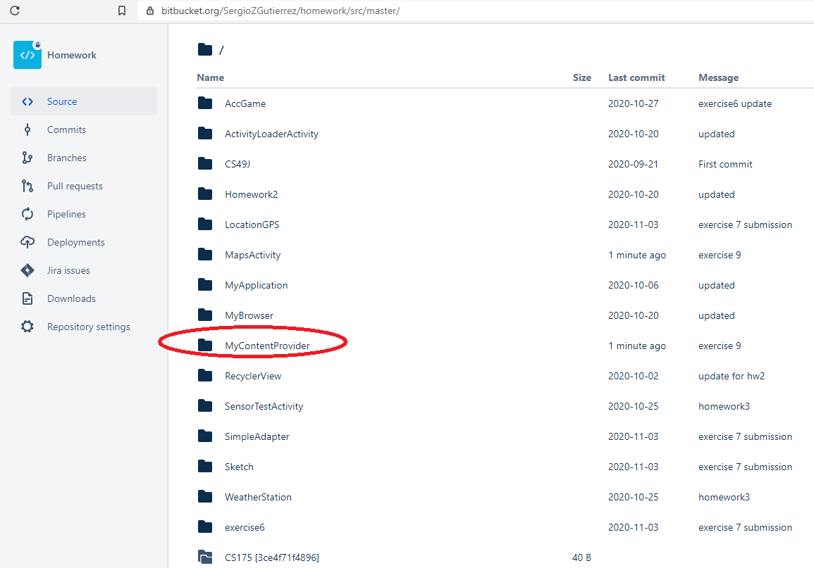

Exercise 8, Adding:

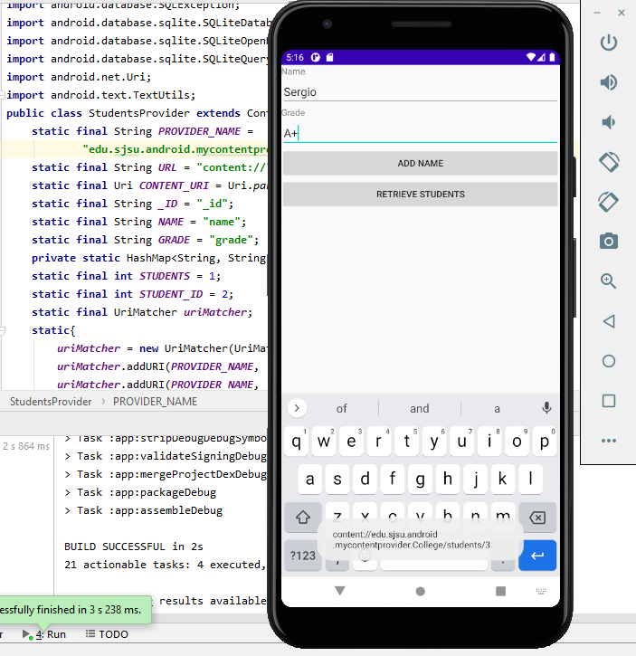

Exercise 8, Retrieving:

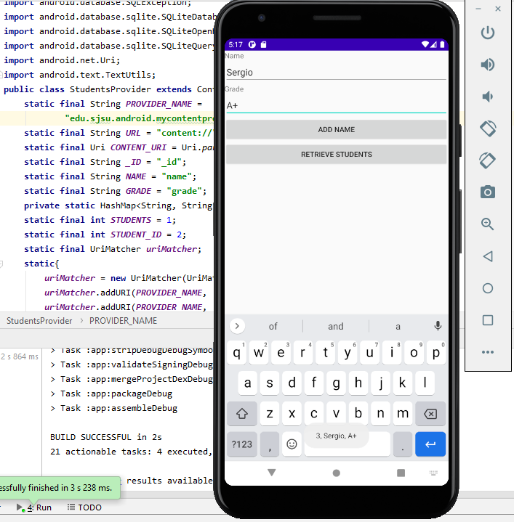

The exact pathway of where the .java files are located in my repository are:

<https://bitbucket.org/SergioZGutierrez/homework/src/master/MyContentProvider/app/src/main/java/edu/sjsu/android/mycontentprovider/>